第十一章:
Hive是Hadoop上的Killer Application,是Hadoop事实上的SQL引擎标准，Hive同时兼具有数据仓库中的存储引擎和查询引擎的作用，Hive最初的计算引擎为MapReduce，受限于其自身的Map+Reduce计算模式，以及不够充分的大内存利用，并且MapReduce的性能难以得到提升，而Spark SQL是一个更加出色的高级查询引擎，因此在现代企业级应用中SparkSQL的分析查询引擎和Hive的数据仓库的存储引擎完美结合成为了业界使用大数据最为高效和流行的趋势，能够非常轻易地满足业务的需求和多变的场景。
从Hive的角度来看，数据就是一张张的Table,我们的操作就是基于SQL的多维度来查询Table，所以如果知道SQL语句的基本操作，基本就能很轻松地使用Hive，从而大大降低了从业人员对大规模数据的分析，关于Hive的具体技术，请大家查阅相关的资料。
在Spark中会将Hive转换成Spark中的Task,而不是MapReduce中的Task
HiveContext是处理Hive的上下文，HiveContext继承于SQLContext,HiveContext重写了SQLContext中的一些方法，包括:
Catalog:由HiveMetoreCatalog替换掉SimpleCatalog，主要是增加了cachedDataSourceTables函数：对Hive元数据进行缓存处理
Analyzer，SparkPlanner(hivePlanner)，getSQLDialect，
ExtendedHiveQ1Parse:代替sqlParser
如图11-00 Hive SQL的执行流程图:
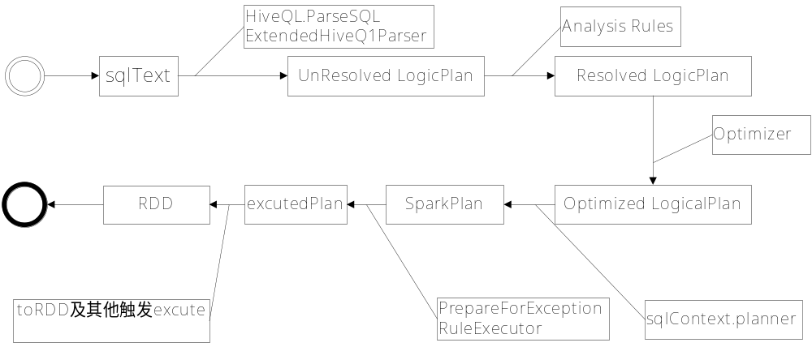

11.1 Ｈive SQL语法解析器
HiveContext覆盖了SQLContext对SQL解析的入口，DDL的解析依然交给了DDLParser，但是Hive SQL则交由HiveQ1.parseSql()方法处理，详细代码见11-01。
代码11-01 HiveContext解析sql的入口:
@transient
protected[sql] val ddlParser = new DDLParser(sqlParser.parse(_))
@transient
protected[sql] val sqlParser = new SparkSQLParser(getSQLDialect().parse(_))
protected[sql] def getSQLDialect(): ParserDialect = {
try {
val clazz = Utils.classForName(dialectClassName)
clazz.newInstance().asInstanceOf[ParserDialect]
} catch {
case NonFatal(e) =>
// Since we didn't find the available SQL Dialect, it will fail even for SET command:
// SET spark.sql.dialect=sql; Let's reset as default dialect automatically.
val dialect = conf.dialect
// reset the sql dialect
conf.unsetConf(SQLConf.DIALECT)
// throw out the exception, and the default sql dialect will take effect for next query.
throw new DialectException(
s"""Instantiating dialect '$dialect' failed.
|Reverting to default dialect '${conf.dialect}'""".stripMargin, e)
}
}
protected[sql] def parseSql(sql: String): LogicalPlan = ddlParser.parse(sql, false)
/* This is the HiveQL Dialect, this dialect is strongly bind with HiveContext*/
private[hive] class HiveQLDialect(sqlContext: HiveContext) extends ParserDialect {
override def parse(sqlText: String): LogicalPlan = {
sqlContext.executionHive.withHiveState {
HiveQl.parseSql(sqlText)
}
}
}
11.2 Hive SQL元数据分析
通过覆写Analyzer覆盖extendedRules，并提供额外的词法检测机制，详细代码如下:11-02
override protected[sql] lazy val analyzer: Analyzer =
new Analyzer(catalog, functionRegistry, conf) {
override val extendedResolutionRules =
catalog.ParquetConversions ::
catalog.CreateTables ::
catalog.PreInsertionCasts ::
ExtractPythonUDFs ::
ResolveHiveWindowFunction ::
PreInsertCastAndRename ::
(if (conf.runSQLOnFile) new ResolveDataSource(self) :: Nil else Nil)
override val extendedCheckRules = Seq(
PreWriteCheck(catalog)
)
}
11.3 Hive SQL 执行Physical Plan
扩展了SparkPlan的执行策略
详细代码如下：11-03
@transient
private val hivePlanner = new SparkPlanner with HiveStrategies {
val hiveContext = self
override def strategies: Seq[Strategy] = experimental.extraStrategies ++ Seq(
DataSourceStrategy,
HiveCommandStrategy(self),
HiveDDLStrategy,
DDLStrategy,
TakeOrderedAndProject,
InMemoryScans,
HiveTableScans,
DataSinks,
Scripts,
Aggregation,
LeftSemiJoin,
EquiJoinSelection,
BasicOperators,
BroadcastNestedLoop,
CartesianProduct,
DefaultJoin
)
}
11.4 Hive SQL与Spark SQL的性能比较
11.4.1使用Hadoop 和Hive SQL执行查询表所花时间:
hive>select count(*) from sogouq1"
Time taken: 54.857 seconds, Fetched: 1 row(s)
hive (hive)> select count(*) from sogouq1;
Query ID = root_20160503232846_fb645e2d-60b1-41e2-8e32-646dd3da5991
Total jobs = 1
Launching Job 1 out of 1
Number of reduce tasks determined at compile time: 1
In order to change the average load for a reducer (in bytes):
set hive.exec.reducers.bytes.per.reducer=<number>
In order to limit the maximum number of reducers:
set hive.exec.reducers.max=<number>
In order to set a constant number of reducers:
set mapreduce.job.reduces=<number>
Starting Job = job_1462288543121_0002, Tracking URL = http://Master:8088/proxy/application_1462288543121_0002/
Kill Command = /usr/local/hadoop/hadoop-2.6.0/bin/hadoop job -kill job_1462288543121_0002
Hadoop job information for Stage-1: number of mappers: 1; number of reducers: 1
2016-05-03 23:29:13,154 Stage-1 map = 0%, reduce = 0%
2016-05-03 23:29:22,672 Stage-1 map = 100%, reduce = 0%, Cumulative CPU 5.78 sec
2016-05-03 23:29:31,936 Stage-1 map = 100%, reduce = 100%, Cumulative CPU 9.81 sec
MapReduce Total cumulative CPU time: 9 seconds 810 msec
Ended Job = job_1462288543121_0002
MapReduce Jobs Launched:
Stage-Stage-1: Map: 1 Reduce: 1 Cumulative CPU: 9.81 sec HDFS Read: 108757523 HDFS Write: 8 SUCCESS
Total MapReduce CPU Time Spent: 9 seconds 810 msec
OK
1000000
Time taken: 47.919 seconds, Fetched: 1 row(s)
所花时间为47.9191 Seconds

11.4.2 Spark SQL 执行时间
scala >hiveContext.sql("select count(*) from sogouq1").collect.foreach(println)
16/05/03 23:44:52 INFO scheduler.TaskSetManager: Finished task 0.0 in stage 3.0 (TID 5) in 439 ms on Worker2 (1/1)
16/05/03 23:44:52 INFO scheduler.TaskSchedulerImpl: Removed TaskSet 3.0, whose tasks have all completed, from pool
16/05/03 23:44:52 INFO scheduler.DAGScheduler: ResultStage 3 (collect at <
:30) finished in 0.442 s
16/05/03 23:44:52 INFO scheduler.DAGScheduler: Job 1 finished: collect at <
:30, took 6.599673 s
第一次执行所花时间为6.599673s
scala >hiveContext.sql("select count(*) from sogouq1").collect.foreach(println)
16/05/03 23:45:35 INFO spark.MapOutputTrackerMaster: Size of output statuses for shuffle 2 is 155 bytes
16/05/03 23:45:36 INFO scheduler.TaskSetManager: Finished task 0.0 in stage 5.0 (TID 8) in 1773 ms on Worker1 (1/1)
16/05/03 23:45:36 INFO scheduler.TaskSchedulerImpl: Removed TaskSet 5.0, whose tasks have all completed, from pool
16/05/03 23:45:36 INFO scheduler.DAGScheduler: ResultStage 5 (collect at < console>:30) finished in 1.775 s
16/05/03 23:45:36 INFO scheduler.DAGScheduler: Job 2 finished: collect at <console>:30, took 5.674897 s
[1000000]
第二次执行的时间为5.67s
综合上两个案例的对比发现SPARK SQL的执行时间远远高于Hive On SQL却多次执行时间将缩短

